**Unit-4**

**3-Ø induction motor**

The [three phase induction motor](http://www.electrical4u.com/working-principle-of-three-phase-induction-motor/) is the most widely used [electrical motor](http://www.electrical4u.com/electrical-motor-types-classification-and-history-of-motor/). Almost 80% of the mechanical power used by industries is provided by three phase induction motors because of its simple and rugged construction, low cost, good operating characteristics, absence of commutator and good speed regulation. In three phase induction motor the power is transferred from stator to rotor winding through induction. The [induction motor](http://www.electrical4u.com/induction-motor-types-of-induction-motor/) is also called A[synchronous motor](http://www.electrical4u.com/induction-motor-types-of-induction-motor/) as it runs at a speed other than the synchronous speed. Like any other electrical motor induction motor also have two main parts namely rotor and stator.

* **Construction of Induction Motor**

A three phase **Induction motor** mainly consists of two parts called as the **Stator** and the **Rotor**.

**Stator:** As its name indicates stator is a stationary part of induction motor. A stator winding is placed in the stator of induction motor and the three phase supply is given to it.

**Rotor:** The rotor is a rotating part of induction motor. The rotor is connected to the mechanical load through the shaft.

## **Construction of Stator**

### The stator is built up of high-grade alloy steel laminations to reduce eddy current losses. It has three main parts, namely outer frame, the stator core and a stator winding.

### Image result for induction motor stator images**Outer frame**

It is the outer body of the motor. Its main function is to support the stator core and to protect the inner parts of the machine. For small machines, the outer frame is casted, but for the large machine, it is fabricated. The stator construction is shown in figure 3.1.

1. 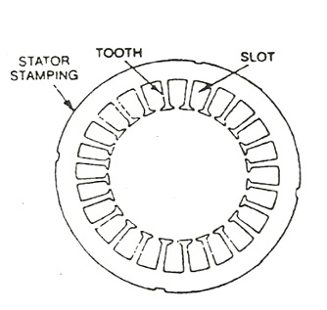**Stator Core**

Figure 3.0‑1 stator outer frame

The stator core is built of high-grade silicon steel stampings. Its main function is to carry the alternating magnetic field which produces hysteresis and eddy current losses. The stampings are fixed to the stator frame. Each stamping are insulated from the other with a thin varnish layer. The thickness of the stamping usually varies from 0.3 to 0.5 mm. Slots are punched on the inner side of the stampings as shown in the figure 3.2.

Figure 3.0‑2 stator core

### **Stator windings**

The core of the stator carries three phase windings which are usually supplied from a three-phase supply system. The six terminals of the windings (two of each phase) are connected in the terminal box of the machine. The stator of the motor is wound for a definite number of poles, depending on the speed of the motor. If the number of poles is greater, the speed of the motor will be less and if the number of poles is less than the speed will be high.

## **Construction of Rotor**

The rotor is also built of thin laminations of the same material as the stator. The laminated cylindrical core is mounted directly on the shaft. These laminations are slotted on the outer side to receive the conductors. There are two types of rotor.

## construction of an induction motor fig 3**Squirrel Cage Rotor**

A squirrel cage rotor consists of a laminated cylindrical core. The circular slots at the outer periphery are semi-closed. Each slot contains uninsulated bar conductor of aluminium or copper. At the end of the rotor the conductors the short-circuited by a heavy ring of copper or aluminium. The diagram of the cage rotor is shown in figure 3.3.

Figure 3.0‑3 Squirrel Cage Rotor

The rotor slots are usually not parallel to the shaft but are skewed. The skewing of the rotor conductors has the following advantages given below.

* It reduces humming and provide smooth and noise free operation.
* It results in a uniform torque curve for different positions of the rotor.
* The locking tendency of the rotor is reduced. As the teeth of the rotor and the stator attract each other and lock.
* It increases the rotor resistance due to the increased length of the rotor bar conductors.

### **Advantages of Squirrel Cage Rotor**

The following advantages of the cage rotor are given below.

* The cage rotor is cheaper, and the construction is robust.
* The absence of the brushes reduces the risk of sparking.
* Its Maintenance is less.
* The power factor is higher
* The efficiency of the cage rotor is higher.

## [construction of an induction motor fig 4](http://circuitglobe.com/wp-content/uploads/2016/01/construction-of-an-induction-motor-fig-4.jpg)**Phase Wound Rotor (or) Slip Ring Rotor**

Figure 3.0‑4 Phase wound (or) Slip Ring Rotor

The Phase wound rotor is also called as Slip Ring Rotor. It consists of a cylindrical core which is laminated. The outer periphery of the rotor has a semi-closed slot which carries a 3 phase insulated windings as shown in figure 3.4. The rotor windings are connected in star.

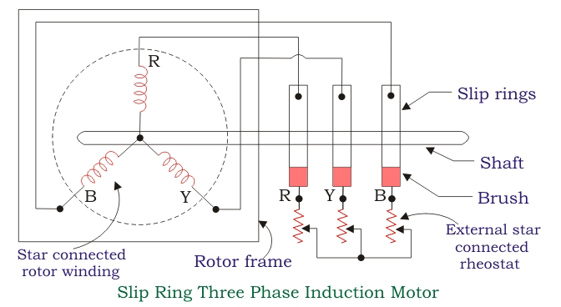

The slip rings are mounted on the shaft with brushes resting on them. The brushes are connected to the variable resistor. The function of the slip rings and the brushes is to provide a means of connecting external resistors in the rotor circuit as shown in figure 3.5. The resistor enables the variation of each rotor phase resistance to serve the following purposes

Figure 3.0‑5 Slip Ring Induction Motor

given below.

* It increases the starting torque and decreases the starting current.
* It is used to control the speed of the motor.

In this type also, the rotor is skewed. A mild steel shaft is passed through the centre of the rotor and is fixed to it. The purpose of the shaft is to transfer mechanical power.

### **Advantages of Phase Wound Rotor**

Following are the advantages of the Phase Wound Rotor.

* High starting torque and low starting current.
* For controlling the speed of the motor, an external resistance can be added in the circuit.

#### **Difference between Slip Ring and Squirrel Cage Induction Motor**

|  |  |
| --- | --- |
| **Slip ring or phase wound Induction motor** | **Squirrel cage induction motor** |
| Construction is complicated due to presence of slip ring and brushes | Construction is very simple |
| The rotor winding is similar to the stator winding | The rotor consists of rotor bars which are permanently shorted with the help of end rings |
| We can easily add rotor resistance by using slip ring and brushes | Since the rotor bars are permanently shorted, its not possible to add external resistance |
| Due to presence of external resistance high starting torque can be obtained | Staring torque is low and cannot be improved |
| Slip ring and brushes are present | Slip ring and brushes are absent |
| Frequent maintenance is required due to presence of brushes | Less maintenance is required |
| The construction is complicated and the presence of brushes and slip ring makes the motor more costly | The construction is simple and robust and it is cheap as compared to slip ring induction motor |
| This motor is rarely used only 10 % industry uses slip ring induction motor | Due to its simple construction and low cost. The squirrel cage induction motor is widely used |
| Rotor copper losses are high and hence less efficiency | Less rotor copper losses and hence high efficiency |
| Speed control by rotor resistance method is possible | Speed control by rotor resistance method is not possible |
| Slip ring induction motor are used where high starting torque is required i.e in hoists, cranes, elevator etc | Squirrel cage induction motor is used in lathes, drilling machine, fan, blower printing machines etc |

* **Rotating Magnetic field (R.M.F.)**

The rotating magnetic field can be defined as the field or flux having constant amplitude but whose axis is continuously rotating in a plane with a certain speed. So if the arrangement is made to rotate a permanent magnet, then the resulting field is a rotating magnetic field. But in this method, it is necessary to rotate a magnet physically to produce rotating magnetic field.

       But in three phase induction motors such a rotating magnetic field is produced by supplying currents to a set of stationary windings, with the help of three phase a.c. supply. The current carrying windings produce the magnetic field or flux. And due to interaction of three phase fluxes produced due to three phase supply, resultant flux has a constant magnitude and its axis rotating in space, without physically rotating the windings. This type of field is nothing but rotating magnetic field. Let us study how it happens.

**Production of R.M.F.**

       A three phase induction motor consists of three phase winding as its stationary part called stator. The three phase stator winding is connected in star or delta. The three phase windings are displaced from each other by 120o. The windings are supplied by a balanced three phase a.c. supply. This is shown in the Figure 3.6. The three phase windings are denoted as R-R’, Y-Y' and B-B'.

|  |
| --- |
| <http://4.bp.blogspot.com/-_hD61BscWck/Te5LuSsOv_I/AAAAAAAAAnI/X8pnfatGrKg/s1600/full180.jpeg> |
| Figure 3.6    Star or delta connected 3phase winding |

       The three phase currents flow simultaneously through the windings and are displaced from each other by 120o electrical. Each alternating phase current produces its own flux which is sinusoidal. So all three fluxes are sinusoidal and are separated from each other by 120o. If the phase sequence of the windings is R-Y-B, then mathematical equations for the instantaneous values of the three fluxes ΦR, ΦYand ΦBcan be written as,

                     ΦR= Φmsin(ωt) = Φmsin θ                                    ...........(1)

                     ΦY= sin (ωt - 120o) = Φmsin (θ - 120o)               ............(2)

                     ΦB= Φmsin (ωt - 240o) = Φmsin (θ - 240o)          .............(3)

       As winding are identical and supply is balanced, the magnitude of each flux is Φm. Due to phase sequence R-Y-B, flux lags behind ΦRby 120o and ΦBlags ΦYby 120o. So ΦBultimately lags ΦRby 240o. The flux ΦRis taken as reference while writing the equations.

       The Figure. 3.7(a) shows the waveforms of three fluxes in space. The Figure 3.7(b) shows the phasor diagram which clearly shows the assumed positive directions of each flux. Assumed positive direction means whenever the flux is positive it must be represented along the direction shown and whenever the flux is negative it must be represented along the opposite direction to the assumed positive direction.

       Let ΦR, ΦYand ΦBbe the instantaneous values of the three fluxes. The resultant flux ΦTis the phasor addition of ΦR, ΦYand ΦB.

[http://3.bp.blogspot.com/-sURuOcD_GxE/Te5Nb4NMF5I/AAAAAAAAAnM/CgCvR0f5cPU/s1600/full181.jpeg](http://3.bp.blogspot.com/-sURuOcD_GxE/Te5Nb4NMF5I/AAAAAAAAAnM/CgCvR0f5cPU/s1600/full181.jpeg)

       Let us find ΦTat the instants 1, 2, 3 and 4 as shown in the Figure. 3.7(a) which represents the values of θ as 0o, 60o, 120o and 180o respectively. The phasor addition can be performed by obtaining the values of ΦR, ΦYand ΦBby substituting values of θ in the equation (1), (2) and (3).

|  |
| --- |
| <http://2.bp.blogspot.com/-kvtb3xwOHO4/Te5N74HY1GI/AAAAAAAAAnQ/3dQXkOZ6W5w/s1600/full182.jpeg> |
| Figure 3.7 |

[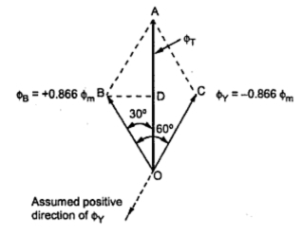](http://4.bp.blogspot.com/-JB2pAk1NYa0/Te5O_CsHmxI/AAAAAAAAAnU/HD77DHAzrew/s1600/full183.jpeg)**Case 1 :**                     θ = 0o  
       Substituting in the equations (1), (2) and (3) we get,  
          ΦR= Φmsin 0o = 0  
          ΦY= Φmsin(-120o ) = -0.866 Φm  
          ΦB= Φmsin (-240o) = + 0.866 Φm

|  |
| --- |
|  |
| Fig.  3.8(a) Vector diagram of  θ = 0o |

The phasor addition is shown in the Figure. 3.8(a). The positive values are shown in assumed positive directions while negative values are shown in opposite direction to the assumed positive directions of the respective fluxes. Refer to assumed positive directions shown in the Figure 3.7(b).

BD is drawn perpendicular from B on ΦT.

It bisects ΦT.  
...             OD = DA =  ΦT/2

In triangle        ∟OBD   = 30o

...                    cos 30o = OD/OB = (ΦT/2)/(0.866 Φm)

...                    ΦT= 2 x 0.866 Φmx cos 30o

                            = 1.5 Φm

[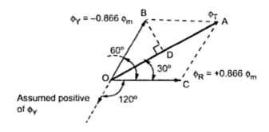](http://2.bp.blogspot.com/-OTQC8PM1si0/Te5P2UvAbCI/AAAAAAAAAnY/IfUxs5qLGUY/s1600/full184.jpeg)       So magnitude of ΦTis 1.5 Φmand its position is vertically upwards at θ = 0o.

**Case 2 :    θ = 60o**

       Equation (1),(2) and (3) give us,

                     ΦR= Φmsin 60o= +0.866 Φm

                     ΦY= Φmsin (-60o) = -0866 Φm

                      ΦB= Φmsin (-180o) = 0

|  |
| --- |
|  |
| Fig.  3.8(b) Vector diagram of  θ = 60o |

       So ΦRis positive and ΦYis negative and hence drawing in appropriate directions we get phasor diagram as shown in the Figure. 3.8(b).

|  |
| --- |
|  |
| Fig  3(b)  Vector diagram of  θ = 60o |

 Doing the same construction, drawing perpendicular from B on at D we get the same result as,

                                   ΦT= 1.5 Φm

       But it can be seen that though its magnitude is 1.5 Φm it has rotated through 60oin space, in clockwise direction, from its previous position.

**Case 3 :    θ = 120o**

[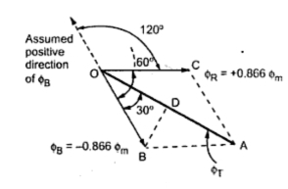](http://4.bp.blogspot.com/-nzeIZ8j84Es/Te5RWjty5sI/AAAAAAAAAnc/ERRxHTdHyWs/s1600/full185.jpeg)       Equations (1),(2) and (3) give us,

                          ΦR= Φm sin 120o = +0.866 Φm

                          ΦY=  Φm sin 0o = 0

                           ΦB= Φm sin (-120o ) = -0.866 Φm

       So ΦRis positive and ΦBis negative. showing ΦRand ΦBin the appropriate directions, we get the phasor diagram as shown in the Figure . 3.8(c).

|  |
| --- |
|  |
| Fig.  3.8(c) Vector diagram of  θ = 120o |

       After doing the construction same as before i.e. drawing perpendicular from B on ΦT, it can be provided again that,

                              ΦT= 1.5 Φm

       But the position of ΦTis such that it has rotated further through 60ofrom its previous position, in clockwise direction. And from its position at θ = 0o, it has rotated through 120o in space, in clockwise direction.

[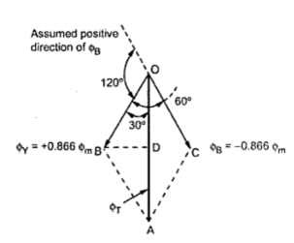](http://3.bp.blogspot.com/-1zL13HZsU1A/Te5Sfualh6I/AAAAAAAAAnk/ZdYUZ5Aib-Q/s1600/full186.jpeg)**Case  4 :     θ = 180o**

       From equations (1),(2) and (3),

                              ΦR= Φm sin (180o) = 0

                              ΦY= Φm sin (60o) = +0.866 Φm

                              ΦB= Φm sin (-60o)

                                  = -0.866 Φm

|  |
| --- |
|  |
| Figure. 3.8(d)  Vector diagram of θ = 180o |

       So ΦR= 0 , ΦYis positive and ΦBis negative. Drawing ΦYand ΦBin the appropriate directions, we get the phasor diagram as shown in the Figure. 3.8(d).

       From phasor diagram, it can be easily proved that,

                              ΦT= 1.5 Φm

       Thus the magnitude of ΦTonce again remains same. But it can be seen that it has further rotated through 60o from its previous position in clockwise direction.

       So for an electrical half cycle of 180o, the resultant ΦThas also rotated through. This is applicable for the windings from the above discussion we have following conclusions:

a) The resultant of the three alternating fluxes, separated from each other by, has a constant amplitude of 1.5 Φm where Φm is maximum amplitude of an individual flux due to any phase.

b) The resultant always keeps on rotating with a certain speed in space.

**Key point:** This shows that when a three phase stationary windings are excited by balanced three phase a.c. supply then the resulting field produced is rotating magnetic field. Though nothing is physically rotating, the field produced is rotating in space having constant amplitude.

* **Principle of Operation**

Three phase induction motor works on the principle of electromagnetic induction. Due to the similarity in the working principle of transformer, it is also known as rotating transformer.

[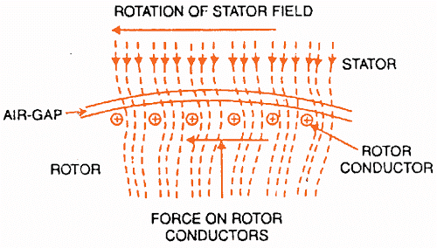](http://1.bp.blogspot.com/-I1mlb3wJthc/VG61p75zkXI/AAAAAAAABNw/wWvo1tLszF8/s1600/Untitled-2-min-min.png)For explaining the principle of operation of a three phase induction motor, consider a portion of three phase induction motor as shown in the figure 3.9.

Figure 3.9 :Portion of Three Phase Induction Motor

When three phase stator winding of an induction motor is energized from a 3 phase supply, a rotating magnetic field is set up which rotates round the stator at synchronous speed (Ns = 120 f/P).

* The rotating field passes through the air gap and cuts the rotor conductors, which as yet, are stationary. Due to the relative speed between the rotating flux and the stationary rotor, e.m.f.s are induced in the rotor conductors. Since the rotor circuit is short-circuited, currents start flowing in the rotor conductors.
* The current-carrying rotor conductors are placed in the magnetic field produced by the stator. Consequently, mechanical force acts on the rotor conductors. The sum of the mechanical forces on all the rotor conductors produces a torque which tends to move the rotor in the same direction as the rotating field.
* The fact that rotor is urged to follow the stator field (i.e., rotor moves in the direction of stator field) can be explained by Lenz’s law. According to this law, the direction of rotor currents will be such that they tend to oppose the cause producing them.
* Now, the cause producing the rotor currents is the relative speed between the rotating field and the stationary rotor conductors. Hence to reduce this relative speed, the rotor starts running in the same direction as that of stator field and tries to catch it.

The rotor speed (N) of a three phase induction motor is always less than the stator field speed (Ns). This difference in speed depends upon load on the motor. The difference between the synchronous speed Ns of the rotating stator field and the actual rotor speed N is called slip.

#### **Synchronous Speed:**

 The rotational speed of the rotating magnetic field is called as synchronous speed.

[Snchronous speed Ns=120f/P](http://3.bp.blogspot.com/-CgfJ5b-rArU/UvRf_APHN9I/AAAAAAAAAUU/Z4ev8dJQmDk/s1600/synchronous-speed.png)

where, f = frequency of the supply

            P = number of poles

#### **Slip:**

Rotor tries to catch up the synchronous speed of the stator field, and hence it rotates. But in practice, rotor never succeeds in catching up. If rotor catches up the stator speed, there wont be any relative speed between the stator flux and the rotor, hence no induced rotor current and no torque production to maintain the rotation. However, this won't stop the motor, the rotor will slow down due to lost of torque, the torque will again be exerted due to relative speed. That is why the rotor rotates at speed which is always less the synchronous speed.

The difference between the synchronous speed (Ns) and actual speed  (N) of the rotor is called as slip.

[slip in induction motor](http://3.bp.blogspot.com/-nLAQQ-vKV4g/UvRcx5KAniI/AAAAAAAAAUI/K5SIPFQDXKE/s1600/slip.png)

At stand still, rotor does not rotate, N = 0, so s = 1.

At synchronous speed, N= Ns, s = 0

The mechanical speed of the rotor, in terms of slip and synchronous speed is given by,

N=(1-s) Ns

**Frequency of Rotor Current and Voltage:**

With the rotor at stand-still, the frequency of the induced voltages and currents is the

same as that of the stator (supply) frequency, fe.

If the rotor rotates at speed of N, then the relative speed is the slip speed:

Nslip=Ns-N

Nslip is responsible for induction. Hence, the frequency of the induced voltages and currents in the rotor is, fr= sfe.

* **EQUIVALENT CIRCUIT :**

The induction motor consists of a two magnetically connected systems namely, stator and rotor. This is similar to a transformer that also has two magnetically connected systems namely primary and secondary windings. Also, the induction motor operates on the same principle as the transformer. Hence, the induction motor is also called as rotating transformer. The stator is supplied by a balanced three-phase voltage that drives a three-phase current through the winding. This current induces a voltage in the rotor. The applied voltage (V1) across phase A is equal to the sum of the

–induced voltage (E1).

–voltage drop across the stator resistance (I1R1).

–voltage drop across the stator leakage reactance (I1 j X1).

Let

I1 = stator current/phase

R1 = stator winding resistance/phase

X1 = stator winding reactance/phase

R2 = stator winding resistance/phase

X2 = stator winding reactance/phase

I2 = rotor current

V1 = applied voltage to the stator/phase

Io = Ic+Im (Im-magnetising component, Ic-core loss component)

The equivalent circuit of any machine shows the various parameter of the machine such as its Ohmic losses and also other losses. The losses are modelled just by [inductor](http://www.electrical4u.com/what-is-inductor-and-inductance-theory-of-inductor/) and [resistor](http://www.electrical4u.com/types-of-resistor-carbon-composition-and-wire-wound-resistor/). The copper losses are occurred in the windings so the winding [resistance](http://www.electrical4u.com/electrical-resistance-and-laws-of-resistance/) is taken into account. Also, the winding has [inductance](http://www.electrical4u.com/what-is-inductor-and-inductance-theory-of-inductor/) for which there is a voltage drop due to inductive reactance and also a term called [power factor](http://www.electrical4u.com/electrical-power-factor/) comes into the picture. There are two types of equivalent circuits in case of a three-phase induction motor-

### **exact equivalent circuitExact Equivalent Circuit**

Figure 3.10 Exact equivalent circuit of three phase induction motor

Exact equivalent circuit of three phase induction motor is shown in figure 3.10.

Here, R1 is the winding resistance of the stator.

X1 is the inductance of the stator winding.

Rc is the core loss component.

XM is the magnetizing reactance of the winding. R2/s is the power of the rotor, which includes output mechanical power and copper loss of rotor. If we draw the circuit referred to the stator,then the circuit will look like as shown in figure 3.11

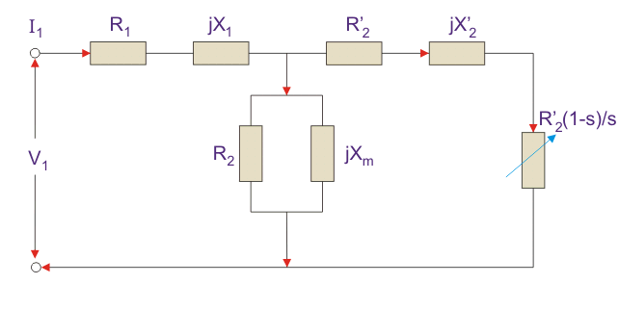Here all the other parameters are same except- R2’ is the rotor winding resistance with referred to stator winding.

X2’ is the rotor winding inductance with referred to stator winding.

R2(1 - s) / s is the resistance which shows the power which is converted to mechanical power output or useful power. The power dissipated in that resistor is the useful power output or shaft power.

Figure 3.11 Circuit Referred to The Stator

### **Approximate Equivalent Circuit**

The approximate equivalent circuit is drawn just to simplify our calculation by deleting one node. The shunt branch is shifted towards the primary side. This has been done as the voltage drop between the stator resistance and inductance is less and there is not much difference between the supply voltage and the induced voltage. However, this is not appropriate due to following reasons-

1. The [magnetic circuit](http://www.electrical4u.com/what-is-magnetic-field/) of induction motor has an air gap so exciting [current](http://www.electrical4u.com/electric-current-and-theory-of-electricity/) is larger compared to transformer so exact equivalent circuit should be used.
2. The rotor and stator inductance is larger in induction motor.
3. In induction motor, we use distributed windings.

This model can be used if approximate analysis has to be done for large motors. For smaller motors, we cannot use this.

## **Power Relation of Equivalent Circuit**

1. Input power to stator- 3 V1I1Cos(Ɵ). Where, V1 is the stator voltage applied. I1 is the current drawn by the stator winding. Cos(Ɵ) is the stator power stator.
2. Rotor input- Power input- Stator copper and iron losses.
3. Rotor Copper loss = Slip × power input to the rotor.
4. Developed Power = (1 - s) × Rotor input power.

# Torque Equation

The torque produced by three phase induction motor depends upon the following three factors:

* The magnitude of rotor current,
* The flux which interact with the rotor of three phase induction motor and is responsible for producing emf in the rotor part of induction motor,
* The power factor of rotor of the three phase induction motor.

Combining all these factors together we get the equation of torque as- T ∝ ØI2COSθ2

Where, T is the torque produced by induction motor, Ø is flux responsible for producing induced emf, E2, I2 is rotor current, and cosθ2 is the power factor of rotor circuit.

The flux Ø produced by the stator is proportional to stator emf E1. i.e Ø ∝ E1 We know that transformation ratio K is defined as the ratio of secondary voltage (rotor voltage) to that of

primary voltage (stator voltage).

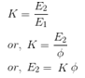

Rotor current I2 is defined as the ratio of rotor induced emf under running condition, sE2 to

total impedance, Z2 of rotor side,



and total impedance Z2 on rotor side is given by,



Putting this value in above equation we get,



s= slip of Induction motor, we know that power factor is defined as ratio of resistance to that of impedance. The power factor of the rotor circuit is



Putting the value of flux Ø, rotor current I2, power factor cosθ2 in the equation of torque we get,



, 

Removing proportionality constant we get,

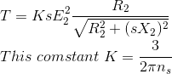

Where ns is synchronous speed in r. p. s, ns = Ns / 60. So, finally the equation of torque becomes,



Derivation of K in torque equation

In case of three phase induction motor, there occur copper losses in rotor. These rotor copper losses are expressed as Pc = 3I22R2

We know that rotor current,



Substitute this value of I2 in the equation of rotor copper losses, Pc. So, we get

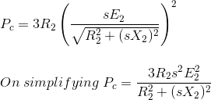

The ratio of P2: Pc: Pm = 1: s: (1 - s)

Where, P2 is the rotor input, Pc is the rotor copper losses, Pm is the mechanical power developed.

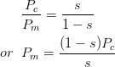

Substitute the value of Pc in above equation we get,



On simplifying we get,



The mechanical power developed

Pm = Tω,

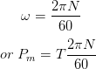

Substituting the value of Pm

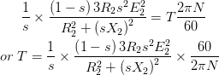

We know that the rotor speed N = Ns (1 - s) Substituting this value of rotor speed in above equation we get,



Ns is speed in revolution per minute (rpm) and ns is speed in revolution per sec (rps) and the relation between the two is



Substitute this value of Ns in above equation and simplifying it we get 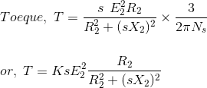

Comparing both the equations, we get, constant K = 3 / 2πns

### **Equation of Starting Torque of Three Phase Induction Motor**

Starting torque is the torque produced by induction motor when it is started. We know that at start the rotor speed, N is zero.



So, the equation of starting torque is easily obtained by simply putting the value of s = 1 in the equation of torque of the three phase induction motor,



The starting torque is also known as standstill torque.

### **Maximum Torque Condition for Three Phase Induction Motor**

In the equation of torque,



The rotor resistance, rotor inductive reactance and synchronous speed of induction motor remain constant. The supply voltage to the three phase induction motor is usually rated and remains constant so the stator emf also remains the constant. The transformation ratio is defined as the ratio of rotor emf to that of stator emf. So if stator emf remains constant then rotor emf also remains constant.

If we want to find the maximum value of some quantity then we have to differentiate that quantity with respect to some variable parameter and then put it equal to zero. In this case we have to find the condition for maximum torque so we have to differentiate torque with respect to some variable quantity which is slip, s in this case as all other parameters in the equation of torque remains constant. So, for torque to be maximum

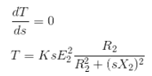

Now differentiate the above equation by using division rule of differentiation. On differentiating and after putting the terms equal to zero we get,



Neglecting the negative value of slip we get



So, when slip s = R2 / X2,

The torque will be maximum and this slip is called maximum slip Sm and it is defined as the ratio of rotor resistance to that of rotor reactance.

NOTE: At starting S = 1, so the maximum starting torque occur when rotor resistance is equal to rotor reactance.

### **Equation of Maximum Torque**

The equation of torque is



The torque will be maximum when slip s = R2 / X2 Substituting the value of this slip in above equation we get the maximum value of torque as,



In order to increase the starting torque, extra resistance should be added to the rotor circuit at start and cut out gradually as motor speeds up.

From the above equation it is concluded that

1. The maximum torque is directly proportional to square of rotor induced emf at the standstill.
2. The maximum torque is inversely proportional to rotor reactance.
3. The maximum torque is independent of rotor resistance.
4. The slip at which maximum torque occur depends upon rotor resistance, R2. So, by varying the rotor resistance, maximum torque can be obtained at any required slip.

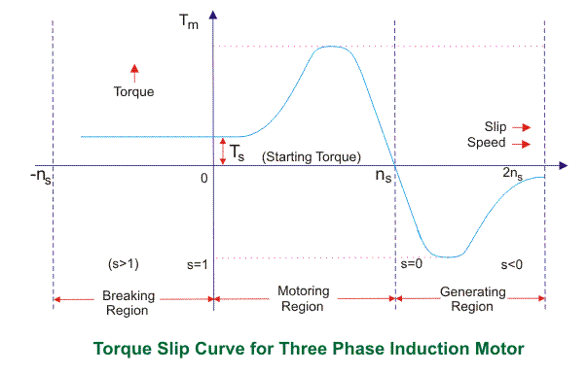

## **Torque Slip Characteristics:**

The torque slip curve for an induction motor shown in figure 3.12, gives us the information about the variation of torque with the slip. The slip is defined as the ratio of difference of synchronous speed and actual rotor speed to the synchronous speed of the machine. The variation of slip can be obtained with the variation of speed that is when speed varies the slip will also vary and the torque corresponding to that speed will also vary. The curve can be described in three modes of operation- The torque-slip characteristic curve can be divided roughly into three regions:

Figure 3.12 Torque – Slip Characteristics

* Low slip region
* Medium slip region
* High slip region

**Motoring Mode:** In this mode of operation, supply is given to the stator sides and the motor always rotates below the synchronous speed. The induction motor torque varies from zero to full load torque as the slip varies. The slip varies from zero to one. It is zero at no load and one at standstill. From the curve it is seen that the torque is directly proportional to the slip. That is, more is the slip, more will be the torque produced and vice-versa. The linear relationship simplifies the calculation of motor parameter to great extent.

**Generating Mode**: In this mode of operation, the [induction motor](http://www.electrical4u.com/induction-motor-types-of-induction-motor/) runs above the synchronous speed and it should be driven by a prime mover. The stator winding is connected to a three phase supply in which it supplies electrical energy. Actually, in this case, the torque and slip both are negative so the motor receives mechanical energy and delivers electrical energy. [Induction motor](http://www.electrical4u.com/induction-motor-types-of-induction-motor/) is not much used as generator because it requires reactive power for its operation. That is, reactive power should be supplied from outside and if it runs below the synchronous speed by any means, it consumes electrical energy rather than giving it at the output. So, as far as possible, [induction generators](http://www.electrical4u.com/induction-generator/) are generally avoided.

**Braking Mode**: In the Braking mode the two leads or the polarity of the supply voltage is changed so that the motor starts to rotate in the reverse direction and as a result the motor stops. This method of braking is known as plugging. This method is used when it is required to stop the motor within a very short period of time. The kinetic energy stored in the revolving load is dissipated as heat. Also, motor is still receiving power from the stator which is also dissipated as heat. So as a result of which motor develops enormous heat energy. For this stator is disconnected from the supply before motor enters the braking mode.

If load which the motor drives accelerates the motor in the same direction as the motor is rotating, the speed of the motor may increase more than synchronous speed. In this case, it acts as an [induction generator](http://www.electrical4u.com/induction-generator/) which supplies electrical energy to the mains which tends to slow down the motor to its synchronous speed, in this case the motor stops. This type of breaking principle is called dynamic or regenerative breaking.

# Losses and Efficiency

There are two types of losses occur in [three phase induction motor](http://www.electrical4u.com/working-principle-of-three-phase-induction-motor/). These losses are,

1. Constant or fixed losses,
2. Variable losses.

## **Constant or Fixed Losses**

Constant losses are those losses which are considered to remain constant over normal working range of [induction motor](http://www.electrical4u.com/induction-motor-types-of-induction-motor/). The fixed losses can be easily obtained by performing no-load test on the three phase induction motor. These losses are further classified as-

1. Iron or core losses,
2. Mechanical losses,
3. Brush friction losses.

### **Iron or Core Losses**

Iron or core losses are further divided into hysteresis and [eddy current](http://www.electrical4u.com/hysteresis-eddy-current-iron-or-core-losses-and-copper-loss-in-transformer/) losses. The core losses depend upon frequency of the supply voltage. The frequency of stator is always supply frequency, f and the frequency of rotor is slip times the supply frequency, (sf) which is always less than the stator frequency. For stator frequency of 50 Hz, rotor frequency is about 1.5 Hz because under normal running condition slip is of the order of 3 %. Hence the rotor core loss is very small as compared to stator core loss and is usually neglected in running conditions.

### **Mechanical and Brush Friction Losses**

Mechanical losses occur at the bearing and brush friction loss occurs in wound rotor induction motor. These losses are zero at start and with increase in speed these losses increases. In [three phase induction motor](http://www.electrical4u.com/working-principle-of-three-phase-induction-motor/) the speed usually remains constant. Hence these losses almost remain constant.

## **Variable Losses**

These losses are also called copper losses. These losses occur due to [current](http://www.electrical4u.com/electric-current-and-theory-of-electricity/) flowing in stator and rotor windings. As the load changes, the current flowing in rotor and stator winding also changes and hence these losses also changes. Therefore, these losses are called variable losses. The copper losses are obtained by performing blocked rotor test on three phase induction motor.

**Power flows in Induction motor through different stages as follows**

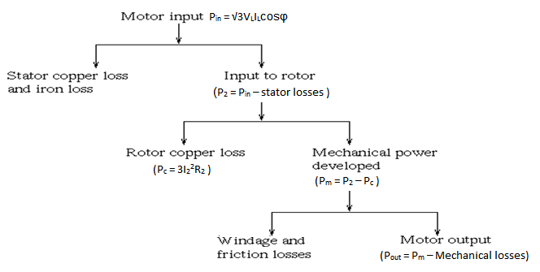

**Efficiency of Three Phase Induction Motor**

Efficiency is defined as the ratio of the output to that of input



Rotor efficiency of the three phase induction motor,



= Gross mechanical power developed / rotor input



Three phase [induction motor](http://www.electrical4u.com/induction-motor-types-of-induction-motor/) efficiency,

Three phase induction motor efficiency